**DATA INGESTION PLAYGROUND VIA SQOOP JOBS (HIVE TO MYSQL)**

Please find the mentioned below steps :

1. Connect to MySql
2. Check the Lab User DB Details.
3. Check Tables in HIVE that you want to Import in MYSQL
4. Import the tables from HIVE Engine to MYSQL Via SQOOP Data Ingestion Tool

Connect to MYSQL

mysql -u edu_labuser -p***** -h dbserver.edu.cloudlab.com

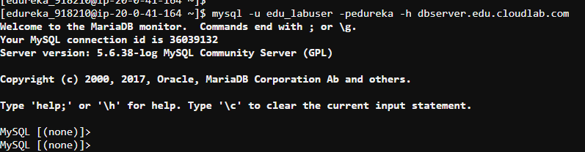

show databases;

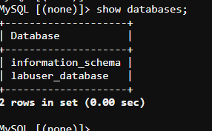

CONNECT TO HUE-HIVE TO CHECK THE TABLES

describe dim_store;

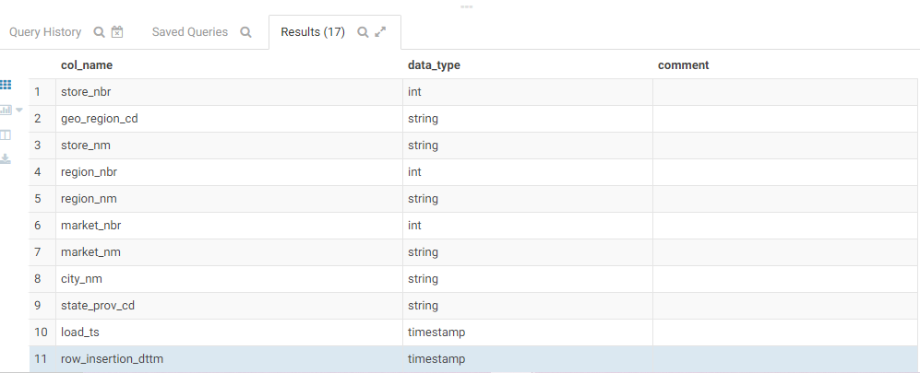

describe sales_amount;

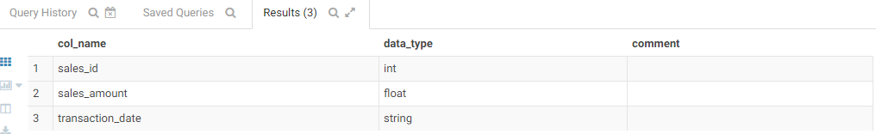

describe fact_sales;

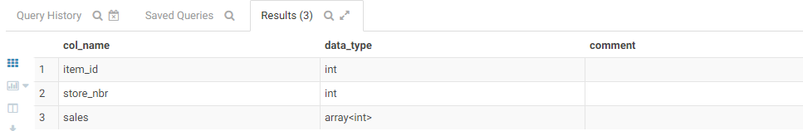

describe dim_item;

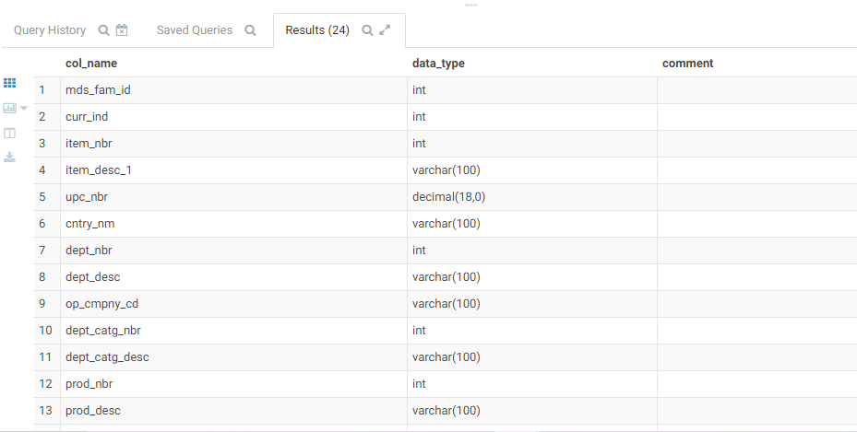

CHECK THE DATA CONTENT OF THE TABLES

select * from fact_sales

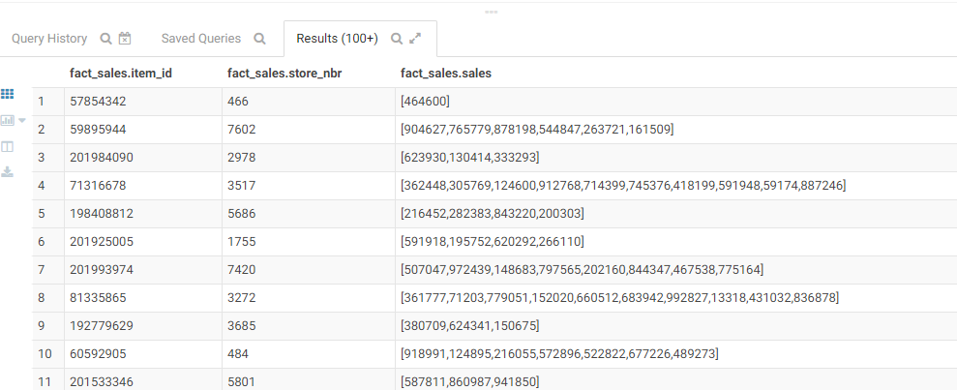

**DATA INGESTION VIA SQOOP JOBS**

First Sqoop Job

sqoop import --connect jdbc:mysql://dbserver.edu.cloudlab.com/labuser_database \

--username edu_labuser \

--password ****** \

--table dim_store \

-m 1 \

--delete-target-dir

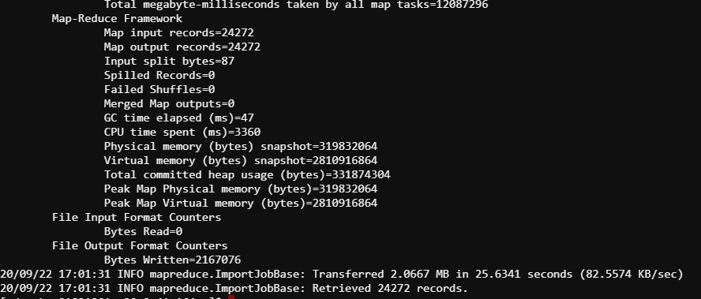

2nd Sqoop Job

sqoop import --connect jdbc:mysql://dbserver.edu.cloudlab.com/labuser_database \

--username edu_labuser \

--password ****** \

--table sales_amount \

-m 1 \

--delete-target-dir

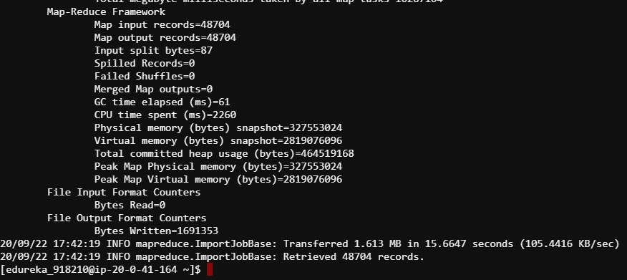

sqoop import --connect jdbc:mysql://dbserver.edu.cloudlab.com/labuser_database \

--username edu_labuser \

--password ******** \

--table fact_sales \

-m 1 \

--delete-target-dir

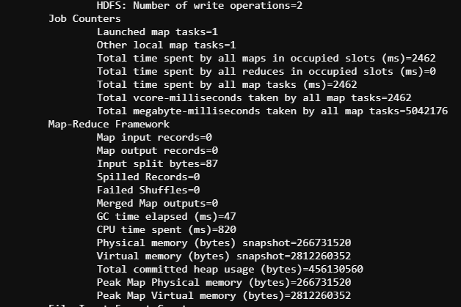

sqoop import --connect jdbc:mysql://dbserver.edu.cloudlab.com/labuser_database \

--username edu_labuser \

--password ******* \

--table dim_item \

-m 1 \

--delete-target-dir

